JSON FILE UPLOADED
Step 1: Login to SnowSQL
snowsql -a <account_name> -u <username> -p <password>
Step 2: Select Database, Schema, Warehouse
Create database json_file;
Use schema public;
Step 3: Create Stage
Create or replace stage json_stage;
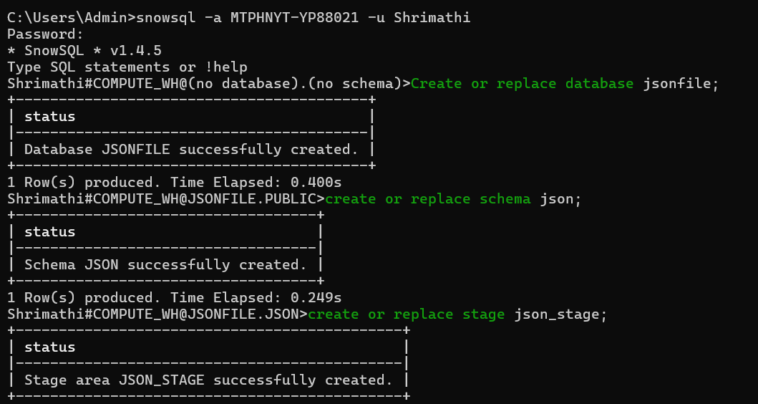
Step 4: Create Table
Create or Replace table employees_json( RAW VARIANT );
Step 5: Create File Format
Create or replace file format FF_JSON_FLAT
TYPE = ‘JSON’
STRIP_OUTER_ARRAY = FALSE;
Step 6: Upload JSON File
PUT 'file://C:/Users/Admin/Downloads/File.json' @json_stage;
Step 7: Copy Data into Table
copy into employees_json from @json_stage/File.json
file_format = (format_Name = 'FF_JSON_FLAT')
ON_ERROR = 'CONTINUE';
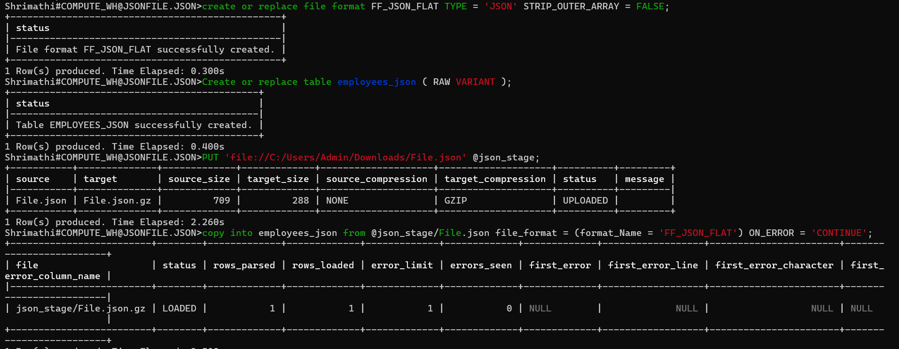

Step 8: Verify Data
Select * from employees_json;
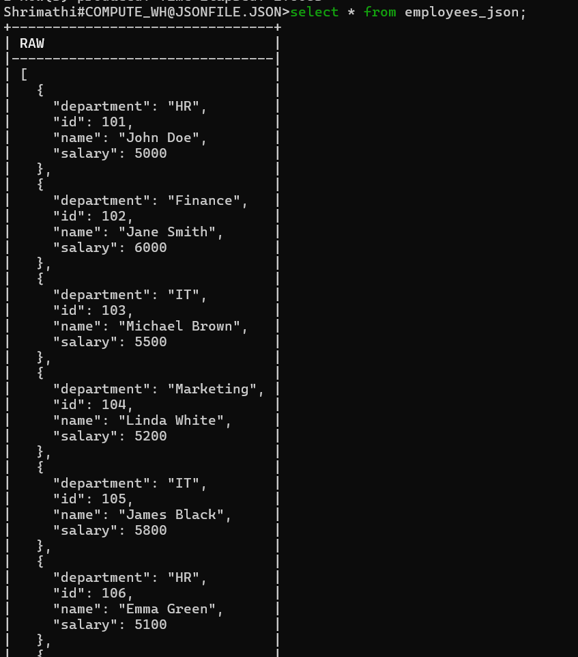
Step 9: Query JSON Fields
SELECT
raw:id::INT AS id,
raw:name::STRING AS name,
raw:department::STRING AS department,
raw:salary::INT AS salary
FROM employee_json;
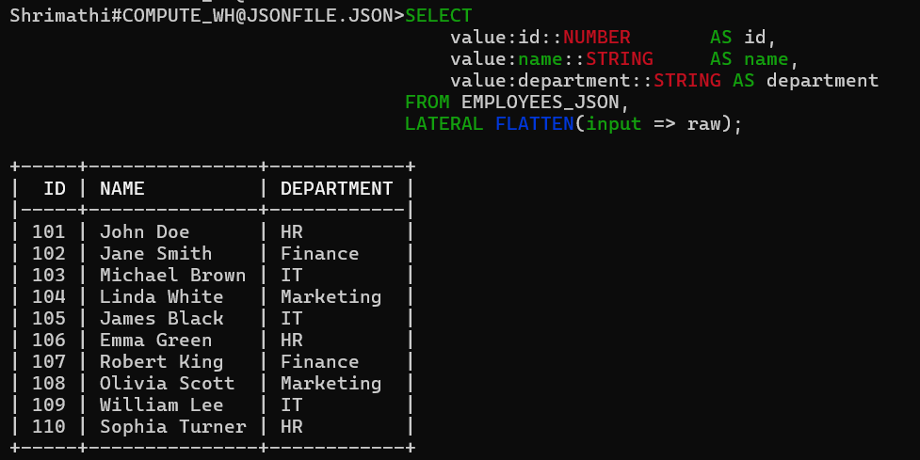
JSON FILE UPLOADED
Step 1: Login to SnowSQL
snowsql -a <account_name> -u <username> -p <password>
Step 2: Select Database, Schema, Warehouse
Use database json_file;
create or replace schema nested_json;
Step 3: Create Stage
Create or replace stage nested_stage;
Step 4: Create Table
Create or Replace table employees_json( RAW VARIANT );
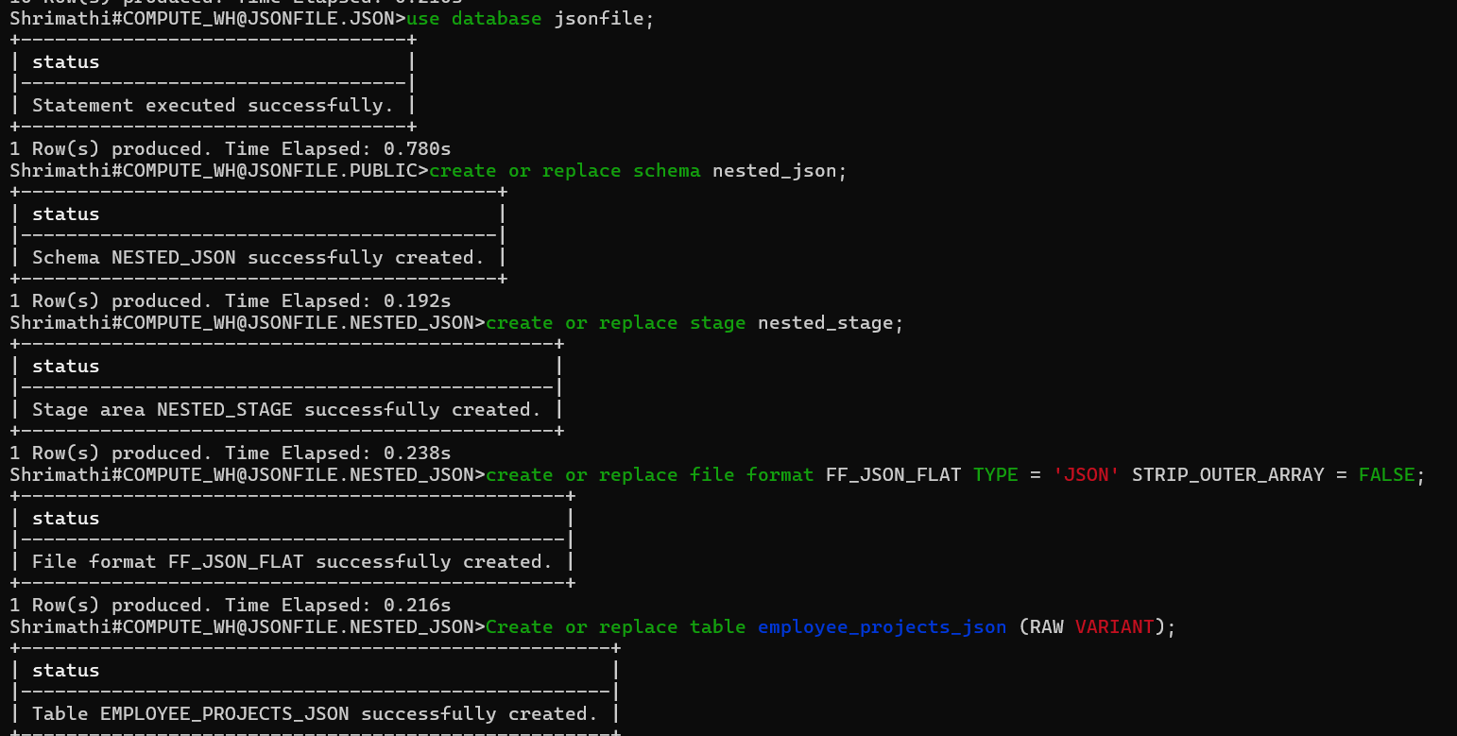
Step 5: Create File Format
CREATE OR REPLACE FILE FORMAT ff_json_flat
TYPE = 'JSON'
STRIP_OUTER_ARRAY = FALSE;
Step 6: Upload JSON File
PUT 'file://C:/Users/Admin/Downloads/Nested_file.json' @nested_stage;
Step 7: Copy Data into Table
COPY INTO employee_project_json
FROM @json_nested/json_ass2.json
FILE_FORMAT = (FORMAT_NAME = 'FF_JSON_FLAT');
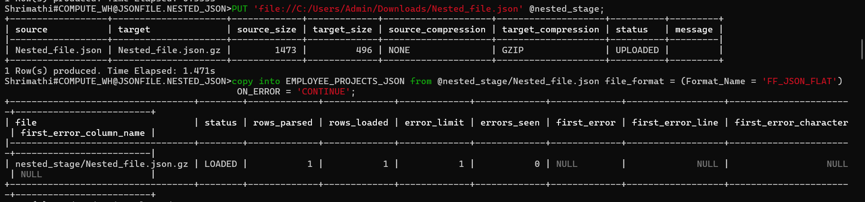
Step 8: Verify Data
SELECT * FROM employee_json;
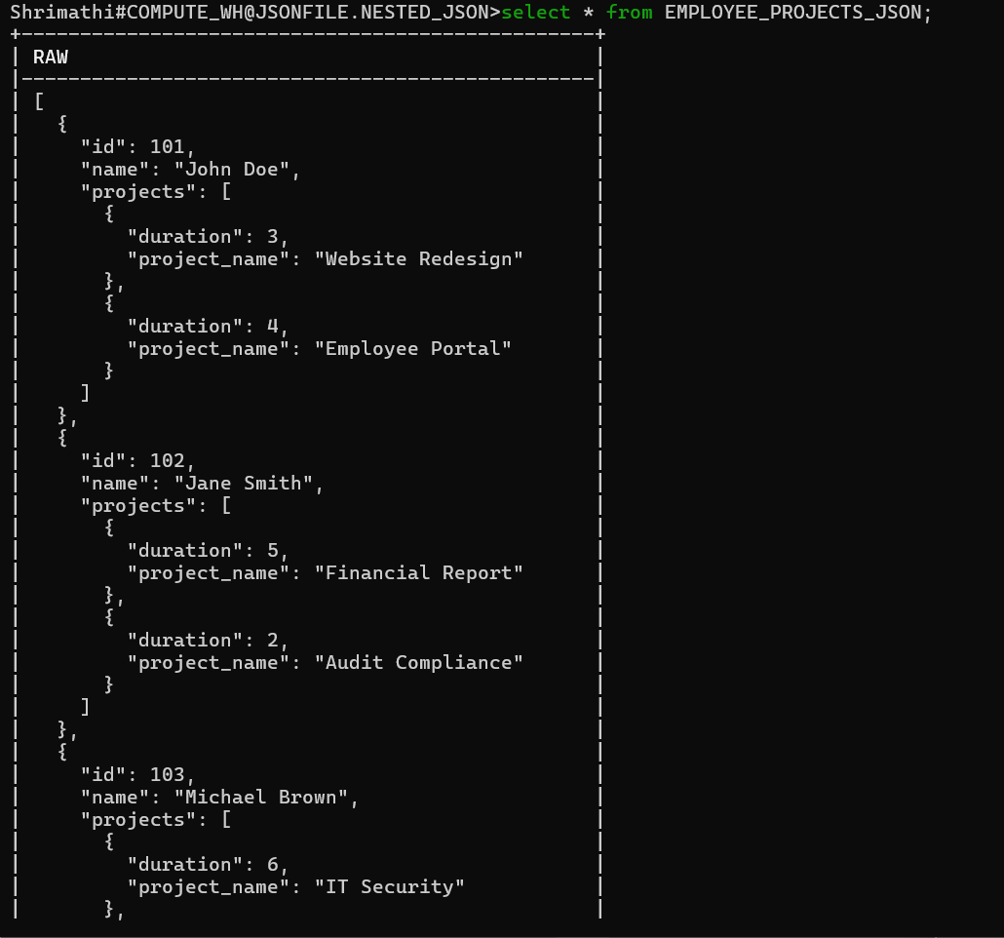
Step 9: Query JSON Fields
SELECT
emp.value:id::int AS employee_id,
emp.value:name::string AS employee_name,
proj.value:project_name::string AS project_name,
proj.value:duration::int AS duration
FROM EMPLOYEE_PROJECT_JSON,
LATERAL FLATTEN(input => raw) emp,
LATERAL FLATTEN(input => emp.value:projects) proj;
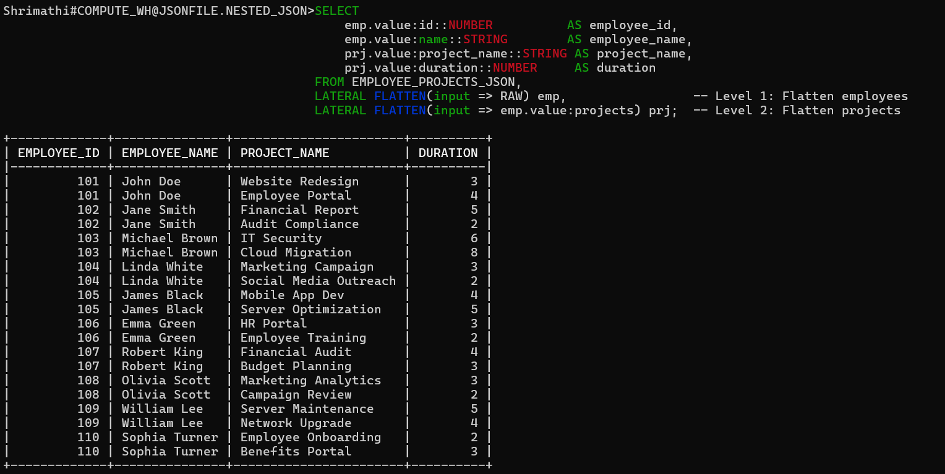
XML FILE UPLOADED
Step 1: Login to SnowSQL
snowsql -a <account_name> -u <username> -p <password>
Step 2: Select Database, Schema, Warehouse
Create database xml_file;
Create or replace schema xmltype;
Step 3: Create Stage
Create or replace stage xmltype_stage;
Step 4: Create File Format
Create or replace file format FF_JSON_FLAT TYPE = ‘XML’
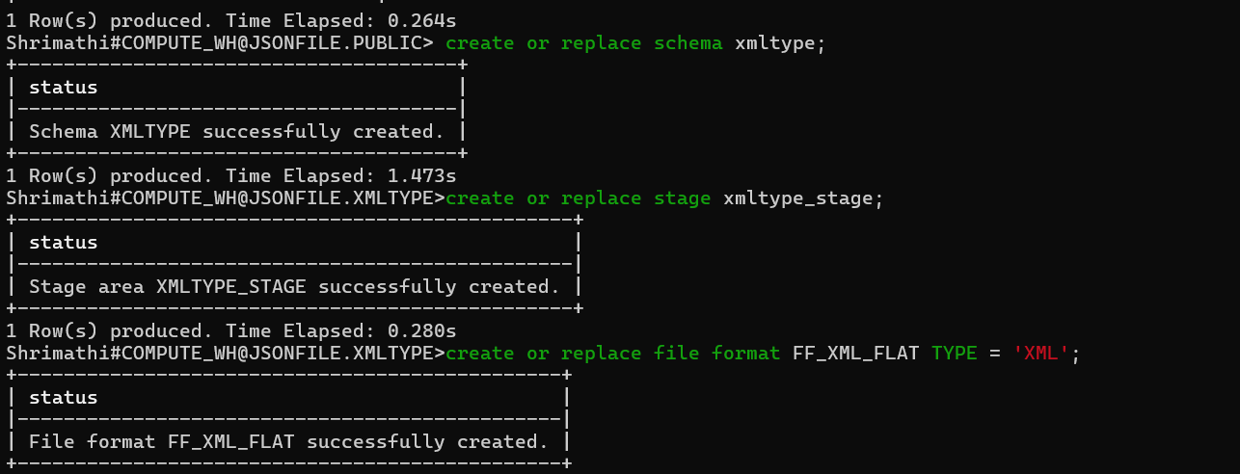
Step 5: Create Table
CREATE OR REPLACE TABLE xml_table (
id INTEGER AUTOINCREMENT,
xml_doc VARIANT
);
Step 6: Upload XML File
PUT 'file://C:/Users/Admin/Downloads/File.xml' @xmltype_stage;
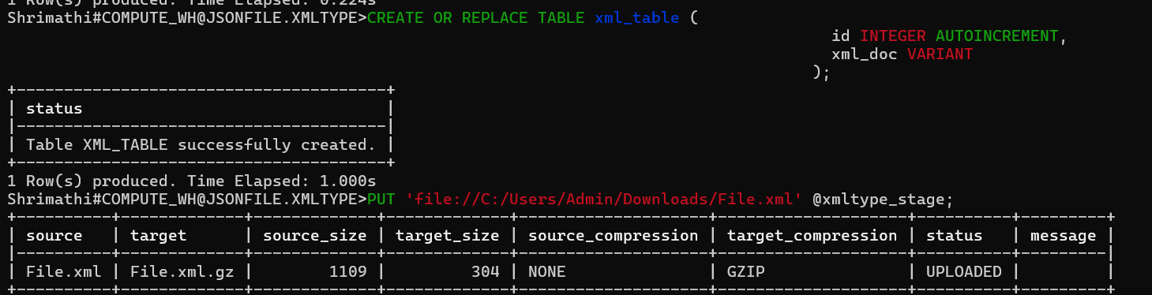
Step 7: Copy Data into Table
copy into XML_TABLE(xml_doc) from @xmltype_stage/File.xml file_format = (Format_Name = 'my_xml_format');

Step 9: Verify Data
select * from xml_table;
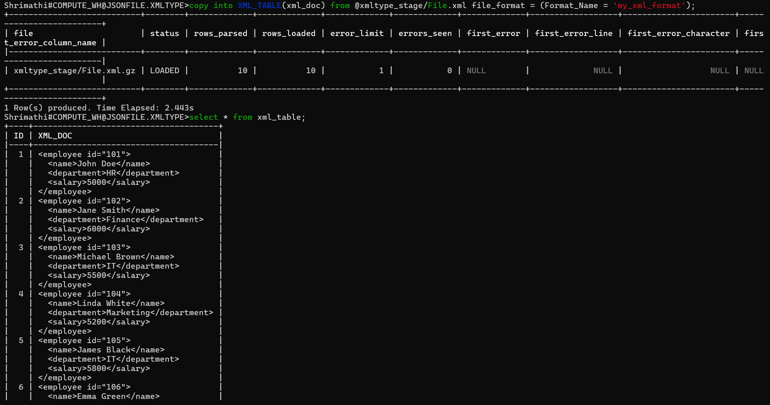
Step 10: Create a table
CREATE OR REPLACE TABLE employees_table (
ID INT,
NAME STRING,
DEPARTMENT STRING,
SALARY INT
);
Step 11: Insert into the table
CREATE OR REPLACE TABLE employees_table (
ID INT,
NAME STRING,
DEPARTMENT STRING,
SALARY INT
);
Step 12: Verify data
select * from employees_table;
